Architecture & Technologies
Citizen Service Center Management Web System

1. Architectural Style
The system adopts a Client-Server Three-Tier Architecture: it is divided into three independent tiers, the presentation tier in the user's browser, the application tier on the server, and the data tier. Each tier communicates only with its adjacent tier.
Reasons for the choice:
- Separation of concerns: the interface, business logic and data are developed independently, so any of them can be modified without affecting the others.
- Security: the browser never reaches the database directly, and all permission restrictions and department isolation are enforced on the server, so they cannot be bypassed by manipulating the interface.
- Fit with the adopted technologies: React maps to the presentation tier, Django to the application tier and PostgreSQL to the data tier.
- Fit with sprint-based development: the application tier is divided into modules by domain, so each sprint adds its module without rebuilding what came before.
Limits of application: the application tier is deployed as a single Django server, i.e. one application divided into internal modules (Modular Monolith), not as separate microservices. This suits the size of an individual graduation project.

2. Architecture Diagram
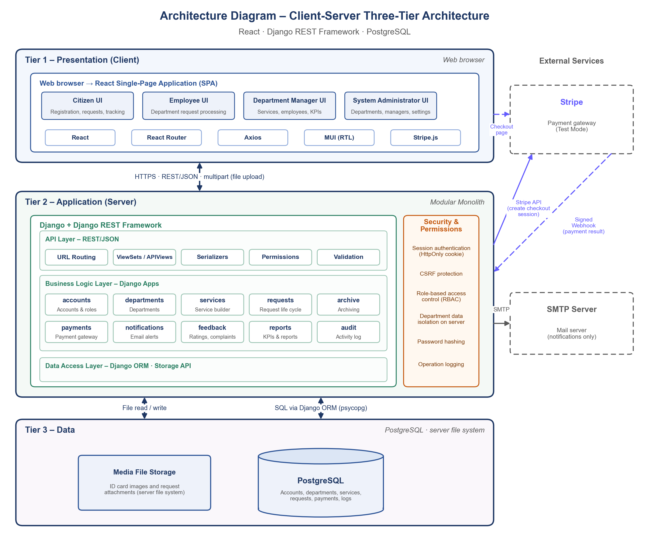

3. Tiers

3.1 Presentation Tier (Client)
A React single-page application running in the user's browser, presenting the interfaces of each role (Citizen, Employee, Department Manager, System Administrator).
- Displaying data and receiving input, with initial format validation to improve the user experience.
- Right-to-left support in all interfaces.
- It contains no business logic and no final permission decision; hiding a button in the interface is not considered protection.

3.2 Application Tier (Server)
A Django server with Django REST Framework, made up of three internal layers:
- API Layer: REST/JSON endpoints, data conversion and validation (Serializers), and permission checks before any operation.
- Business Logic Layer: independent Django modules for each domain (Section 5), including the request state machine rules, routing requests to departments and routing complaints.
- Data Access Layer: Django ORM for the database, and the storage interface for files.
- Security (cross-cutting all layers): session authentication, CSRF protection, role-based access control (RBAC), department data isolation in every query, password hashing and operation logging.

3.3 Data Tier
- PostgreSQL: the relational database for all system data, following each sprint's ERD.
- File storage: ID card images and request attachments are stored in the media folder on the server, not inside the database; only their path is stored. They can be downloaded only through the server after a permission check.

4. Adopted Technologies
Component | Technology | Purpose
User interface | React | Building a single-page application (SPA) with separate interfaces for each role.
Page navigation | React Router | Page routing and protection of each role's routes in the interface.
Server communication | Axios | Sending REST/JSON requests and uploading files (multipart) with the CSRF token attached.
Component library | MUI (RTL) | Ready-made UI components with right-to-left support for the Arabic interface.
Payment on the client | Stripe.js / Stripe Checkout | Redirecting the citizen to Stripe's test checkout page.
Application server | Django | Business logic organized into modules (apps), one per domain.
Application programming interface | Django REST Framework | Endpoints, input validation and permission checks.
Authentication | Django Sessions + CSRF | A server-side session with an HttpOnly cookie, with CSRF protection.
Database | PostgreSQL | Storing relational data: accounts, departments, services, requests, payments, logs.
Data access | Django ORM (psycopg) | Working with the database without hand-written SQL, and managing migrations.
File storage | Django File Storage | Storing ID card images and request attachments in the media folder on the server.
Payment on the server | stripe-python + Webhook | Creating the checkout session and confirming its result with a signed notification.
Email | Django Email (SMTP) | Sending email notifications only.
Version control | Git | Tracking the source code and linking each increment to a sprint.

5. Server Modules and Their Sprints
Module (Django App) | Sprint | Responsibility
accounts | Sprint 1 | Accounts, authentication, roles and the two ID card images.
departments | Sprint 1 | Departments, their managers and data isolation by department.
audit | Sprint 1 (views in Sprint 5) | Logging operations and displaying logs to managers.
services | Sprint 2 | Dynamic service building and the service catalog.
requests | Sprints 2 – 4 | The request life cycle: decisions, then submission, then assignment and tracking.
archive | Sprint 3 | Archiving requests with their attachments, and searching them.
payments | Sprint 3 | Payment through Stripe in its test environment behind a unified interface.
notifications | Sprint 4 | Email and in-system notifications and overdue alerts.
feedback | Sprint 5 | Ratings, complaints and their handling workflow.
reports | Sprint 5 | Performance indicators and reports.

6. Communication Between Tiers
- Presentation ↔ Application: HTTPS with REST/JSON, and file uploads as multipart/form-data.
- Application ↔ Data: SQL queries through Django ORM, and reading and writing files through the storage interface.
- Application ↔ Stripe: the server creates the checkout session through the Stripe API, the browser is redirected to the test checkout page, and Stripe then confirms the result to the server with a signed Webhook.
- Application → Mail server: sending notifications through SMTP in one direction.

